Provisional User's credentials

To sign in to your PICMI application using a provisional user:

- Go to jobs.picmi.io/go
- Enter access code and name
- Check “I agree”
- Click Confirm And Start

Proceed through to job

For Email question answer <enter email address>
(note: the contract will be sent to this email address)
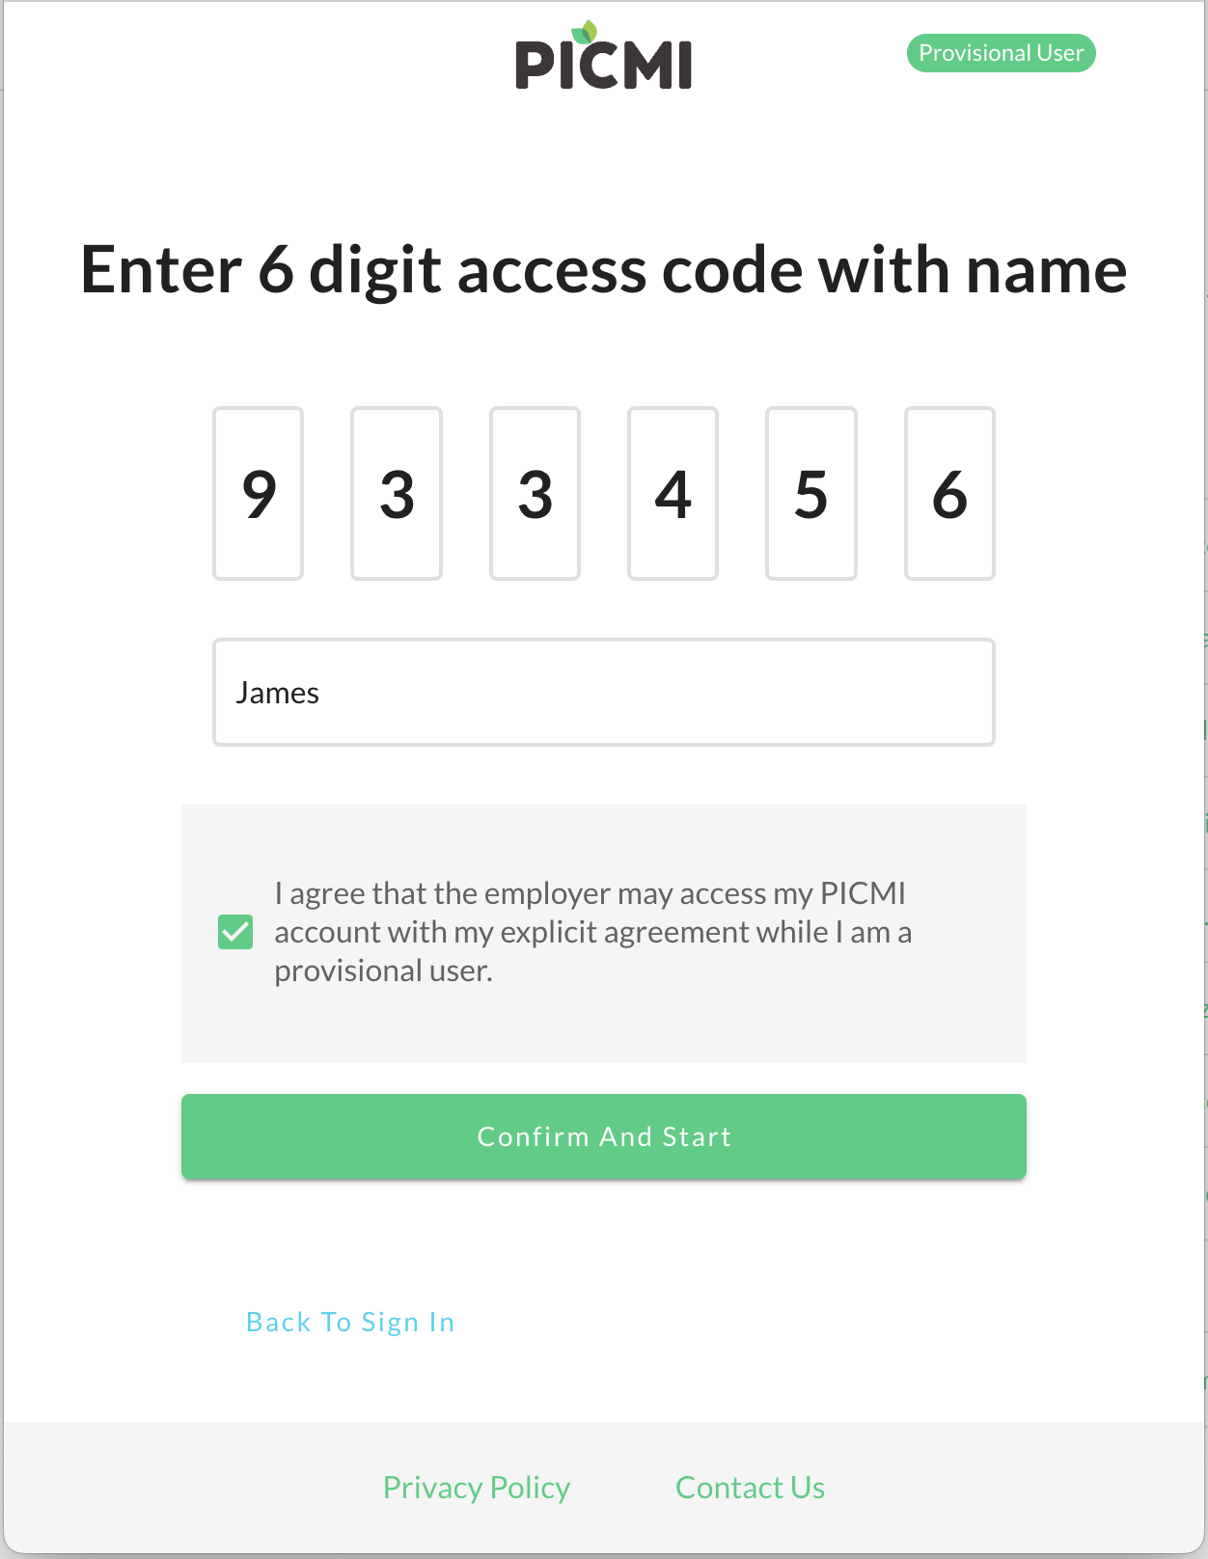

Copy and paste the access keys and codes here
